Agent will order the parts order.

Parts order will perform on the “trace items” not with the system and sub block.

Create a case on the Structured IP.

Create a case on the “System” . &

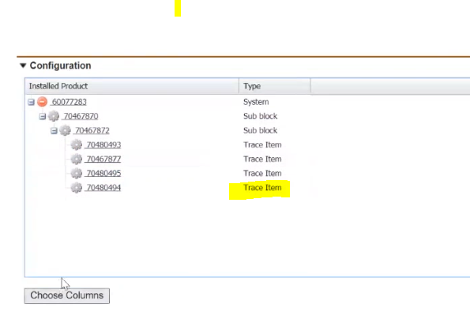

1. Parts order is two type
2. Returnable type and another type is non-returnable

Open any product and check the Service Information where the Logistic handing Group

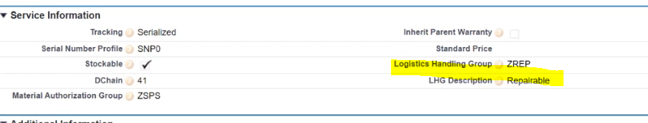

|  |  |
| --- | --- |
| Logistics Handling Group type | Purpose |
| ZSID | Non-Returnable (scrape  ) |
| ZRET | Returnable |
| ZREP | reparable |
| ZRFA | for analysis |

Follow table for more information.

b) if the Serialized then we have to mandatorily fill the Serial number. And Service max,

SAP should maintain Serial number

if it is not serialized then we don’t need to fill the Serial number.

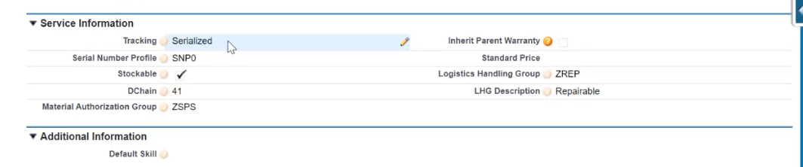

Steps:

1)Click on the Initiate work order.

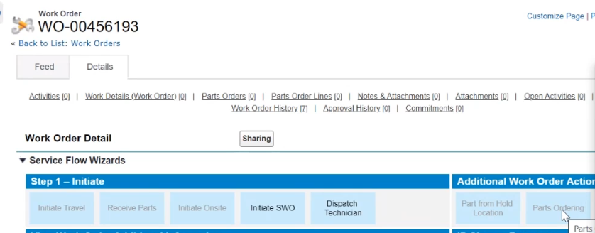

2)Click on the parts ordering

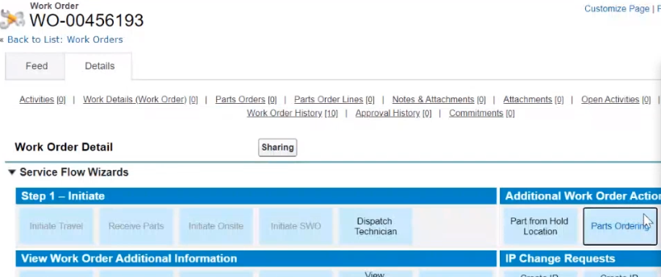

3)You have give the product code of the product and click on search

Note: While searching , remove additional blanks which are at the product code.

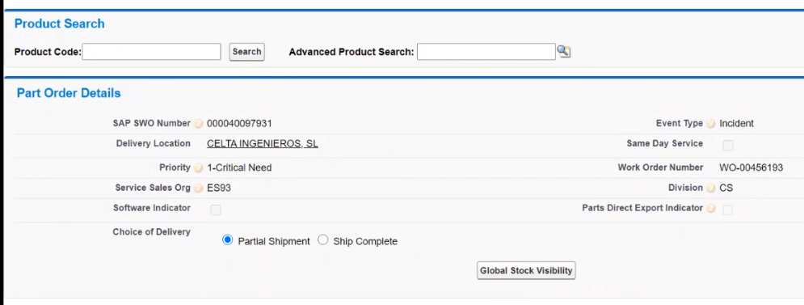

3a)Click on Add button,

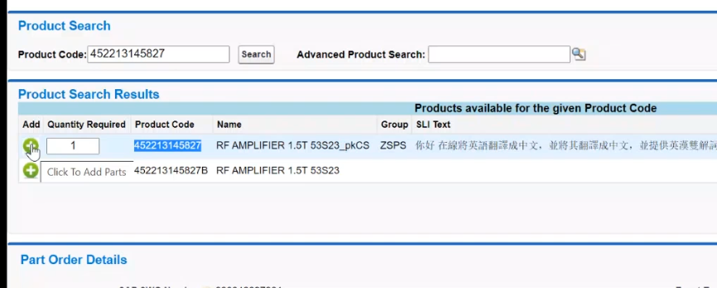

4)Scroll down, and check the added product and do the Entitlement.

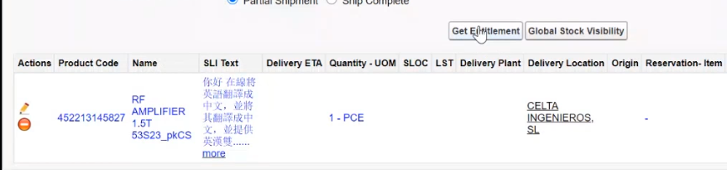

If we see the success message then , the added product is covered under the Entitlement.

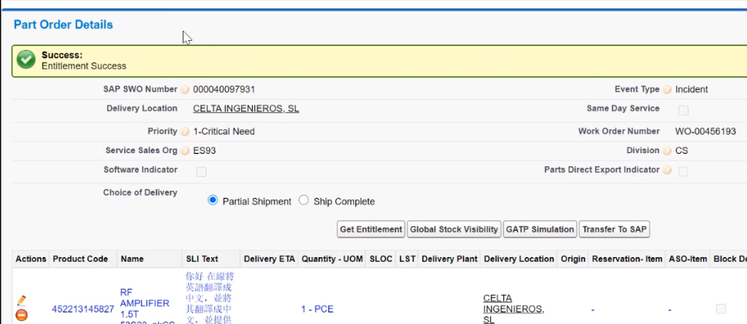

4a) Click on the GATP Simulation, here the added product will check for the stock availability.

And you can see the success message

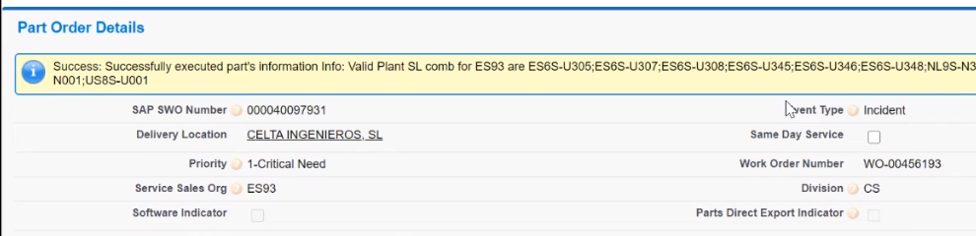

4b)Click on the “Transfer To SAP” and Ask SAP team to do the PGI by providing the ASO-Item number.

Post completion of PGI (, post goods issue), We get one work order with Shipped line created.

Check the Delivery ETA , and should populate the with date , if it is back data means we can’t

Perform the PGI from SAP.

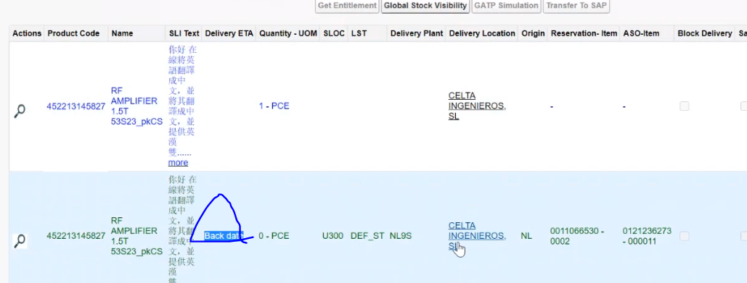

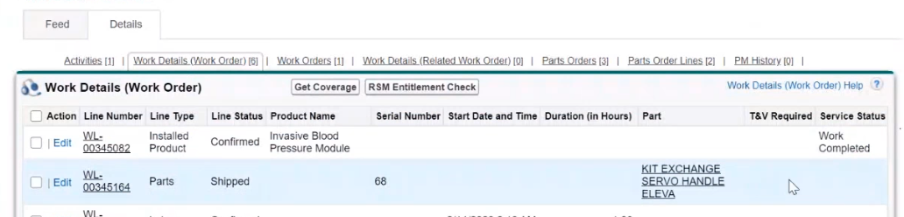

We to dispatch is WO to technician

Click on the